JOB NARRATIVE
- Job Purpose and Roles and Responsibilities of the Job
- Organisation Structure, Outcomes/Value Add, Financials & Work Relations

Basic Details
Job Title | Officer – HR
Job Grade/ Level
Function | HR
Business Sector | Industrial Chemical
Location | Dahej
Occupied/ Vacant | New
Name of the Job Holder (Current, if occupied) | Vacant
Date (Last updated)
Approved by | Mr. Rajendra Thorat

Organisation Structure
(where does the position stand in the organisation structure of the Business)
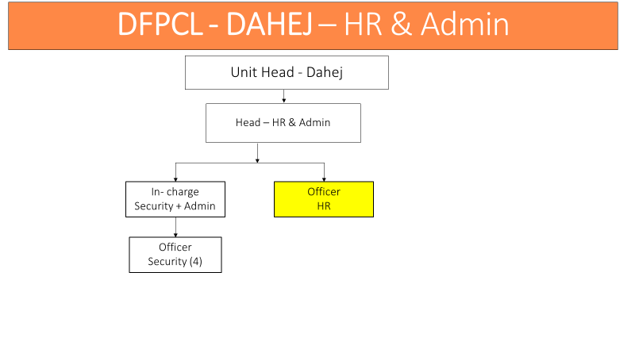
Job Purpose:
- Summarizes the main points of the job description which may include key responsibilities, functions, and duties
- Job Purpose is the prime objective for which the Job holder is responsible for. It is directly controlled by the Job holder
- Should contain 1 - 3 key points
- To establish Reputation & Brand of HR for dahej. This role is primarily responsible for attracting and acquiring talents for all the function of dahej as per budget. This role is also responsible to develop and retain talents by organising trainings and activities for employee connect and employee engagement activities & building healthy and strong employee relations in Dahej.
- This position is responsible for Compensation & Benefits, MIS & Contract labor Management also.

Key Accountabilities & Outcomes
Key Accountability | Major Activities/ Tasks
- TALENT AQUISITION  - INDUCTION AND ORIENTATION OF NEW JOINEES  - FULL & FINAL SETTLEMENT  - TO ORGANISE AND CORDINATE TRAINING  - Organising Events  - Employee Engagement Activities  - Coordinate PMS  - Time & Payroll Management.  - Statutory Compliance | - Designs, develops and maintain the recruitment process in the organization (including its description, recruitment measurement definitions, regular measurement reporting, taking proper actions to close gaps)  - Designs the selection matrix for choosing the optimum recruitment channel and recruitment source  - Conducts job interviews for the managerial job positions (or key jobs in the organization)  - Monitors the labor legislation and implements required changes to keep the process compliant  - Acts as a single point of contact for managers regarding recruitment topics.  - Complete the joining formality (documentation), preparing personal files, verification of documents of new joiners, hand over welcome kit which is comprises of JD, KRA, Telephone list across DFPCL, Uniform and Safety PPE’s.  - Management of employee attrition, Full & Final Settlements timely, conducting exit interviews, developing employee retention schemes  - Coordinate with various functional departments to identify gaps in skills and capabilities among the employees.- Identifying training needs. Collecting data based on PRAISE Forms  - Keep track of changes (organizational/process related etc) in various functions and the impact would have therefore on training needs.  - Carry out a detailed costing for each of the training programs needed to meet the  - Organise and coordinate OPEN HOUSE monthly. Reward & Recognition of employees through SHABASH Card distribution, Felicitation programme for winners & runner up of various events.  - Contribution and intimation of Unit’s news, information, Article for REACH OUT.  - Organise and coordinate the Annual Family GET TOGETHER & PICNIC for employees.  - Celebration of Dassera, Diwali, Women’s day, Mother’s day, Sports Day, Marathon, Trekking etc.  - To prepare events calendar  - To organise the events & activities for engagement  - To conduct Pratisad Analysis, Stay Interviews, quarterly surveys for HR /  - Create and/or edit tools, training materials, and resources to help partners and leaders successfully build action plans based on survey results  - Leverage events to create and sustain dialogue around engagement  - Responsible to time and payroll processing for on roll employees + Trainees. & Resolve all queries with the help of Payroll team during salary processing.  - Maintain & submit month MIS contains data of Manpower, Attrition, Recruitment, Over Time & Admin Budget with attractive form  - Submit statutory returns and claims under various Acts such as:-

Work Relations (Internal and External)
Internal Relations  - Main interface of the Job Holder (Working relationships with Key stakeholders/ internal customers  - Other Job Holders that the Job holder have may to liaise, report or coordinate with | External Relations  - Main interface of the Job Holder (Working relationships with Key stakeholders/ external customers
- All dept.  - Corporate HR | - Consultants,  - Collage Admin for campus hiring

Key Dimensions
Financial Dimensions  - List the significant numerical data which will reflect the scope and scale of activities concerning this job such as budget, cost, revenue etc. | People Dimensions  - Mention the team size (direct reportees only) the Job Holder would have to manage for the scope of activities concerning to this role
- Recruitment & Training budget | - Nil

ACHIEVEMENT PROFILE
- What are the capabilities required by the Job Holder at this position?
- Specify Knowledge (technical expertise), experience, skills, behavioural competencies, personality required
- It depicts candidate profile for making hiring decision and helps incumbent profile for competency mapping

Education Qualifications / Background
- State minimum qualification required by the Job Holder to work effectively on this position
- Graduate or Post Graduation in HR
Relevant and Total Years of Experience
- Mention years of experience required for the job
- Elaborate more of the relevance / type of the job experience required by the role
- 3-8 years of industrial experience.
Technical/Functional Expertise
- Stare minimum proficiency required on specific technical or functional skills required for the Job Role
• Negotiation skill
• Knowledge of HR policies, systems and processes
• Ability to coordinate with different departments and external agencies
• Exposure to the best hiring practices in other industries.
• Effective communication skills, Interpersonal and presentation skills
• Knowledge of portal handling and awareness of current trends in market of using of manpower
Behavioural Competencies (List only 3- 5 specific behavioural competencies)
- State behavioural competencies required to function effectively at this position
- Positive approach
- Good team player
- Disciplined
Personality (List only 3- 5 specific personality characteristics)
- Write personal characteristics/ personality type that is suitable to work at this job level.

- Communication Skills
- Presentation & Interpersonal Skills

